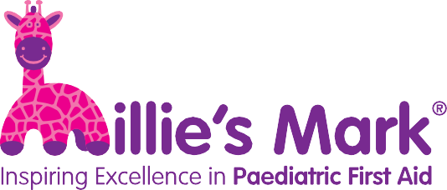

Information for parents

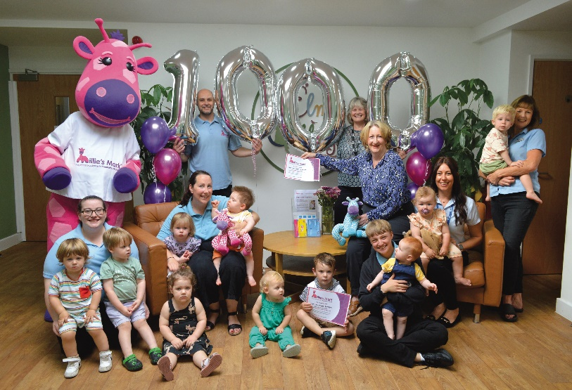
What is Millie’s Mark?
As a parent, placing your child in an early years setting that is endorsed with Millie’s Mark provides reassurance that all childcare practitioners know what to do in a paediatric first aid situation.
It acknowledges that children’s safety is at the forefront of the setting’s mind when they care for your child.
The Early Years Foundation Stage (EYFS) guidelines, which childcare setting in England are required to follow, currently state that just one person with a current paediatric first aid certificate must be on the premises and available at all times when children are present or on outings.
Millie’s Mark is a special endorsement for childcare providers who go above and beyond these minimum requirements by having 100% of staff trained in paediatric first aid. They also ensure that everything that they have learned during the course is kept in the forefront of practitioners’ minds so that they are confident, ready and capable.
Millie’s Mark is named after Millie Thompson, who died after choking on food at nursery in 2012 when she was just none months old. Read more about Millie’s legacy at https://www.milliesmark.com/about-us
National Day Nurseries Association (NDNA) delivers Millie’s Mark in conjunction with Millie’s Trust.

How does an early years setting achieve Millie’s Mark?

In order to apply for Millie’s Mark, 100% of your staff working directly with children must be qualified in paediatric first aid. The accreditation process takes between three and six months.
The process involves the setting checking that processes and procedures meet the required standards through a setting audit, staff confidence audit, staff training matrix, and a risk assessment including a floor plan review.
Once these steps are complete, nurseries upload evidence to the Millie’s Mark website. The evidence is assessed by a panel attended by representatives from Millie’s Trust and NDNA. A percentage of nurseries receive a spot check.

Information for parents V0.2 – 27 August 2025

Awarded setting testimonials

Many settings have shared their experiences of achieving Millie’s Mark, showing how the process has made their staff more confident and has reassured parents. Some highlights are below and you can read the full case studies at https://www.milliesmark.com/case-studies
“Since being accredited with Millie’s Mark, many parents have commented on how reassuring it is to know that we are all competent and confident and that we can respond to an emergency appropriately if it arises. Many potential clients have also seen that we have been awarded with this and are impressed – sometime awards like this can be the decider for parents between us and other nurseries” – Clarence House Chatteris

“As well as being fantastic for our current families, new parents have chosen our setting as we are able to demonstrate our commitment to keeping children safe. Millie’s Mark has had a massive impact on our sustainability, alongside boosting staff confidence. Parents are reassured in the knowledge that, when their children are left with us, their well-being is our biggest priority” – Barton Moss Nursery

“Practitioners are delighted and have been highly motivated as a team to achieve Millie’s Mark. Our parents continue to have the reassurance their children are safe indoors and outdoors across the whole nursery because of the skill and training of our staff team” – Hipperholme & Lightcliffe Day Nurseries Ltd.

Parent testimonials
“My son’s nursery in Stockport has just been awarded Millie’s Mark. I just wanted to send you a note for Millie’s parents to say thank you – and congratulations – for having the strength to come up with such a worthwhile organisation in Millie’s memory. You’ve made the environment my two-year-old son is cared for in much safer, so thank you” – Richard, dad of a child at a Millie’s Mark accredited nursery

Reacting to her child’s nursery achieving Millie’s Mark, parent Suzanne Cheshire said, “Leaving a child at nursery whilst going to work is so much easier knowing they are in such good hands, well done Hipperholme & Lightcliffe.”

Read more about Millie’s Mark at www.milliesmark.com

